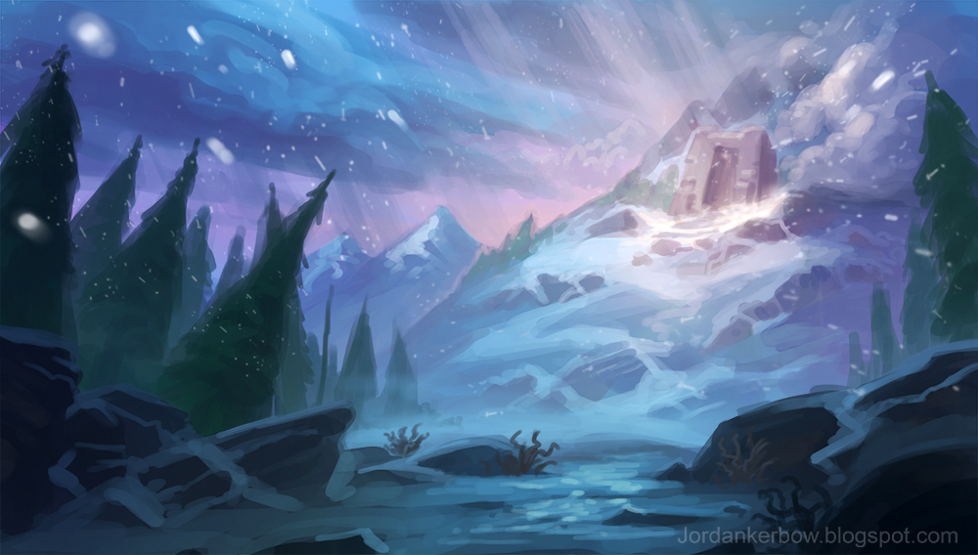**Thorin Frosthelm**

The story of Thorin Frosthelm started in his home Jomsborg, known as the fortress in the cold and harsh weather in the dwarven regions. The home in which the frosthelm train for battle and live their normal lives. Thorin was the youngest son among the 3 children of the king. For the people he was known as greedy, stubborn, and hot-headed. A prideful boy who always gets what he wants. As he grow-up he attitude got worse and worse. The king ashamed and furious to what his son has become decided he needed to disciplined and learn the importance of the name he carries. He puts Thorin in the hands of his generals and said "train this childish dwarf into a warrior". Thorin begged his father to let him return and he shall change. The king shouted "NO, all your life you have been a pain in the ass this the only way you will learn, return to me a warrior and you shall be a frosthelm. Thorin tried to talk but the king disrupts him and said “SILIENCE!” and left him in the barracks.

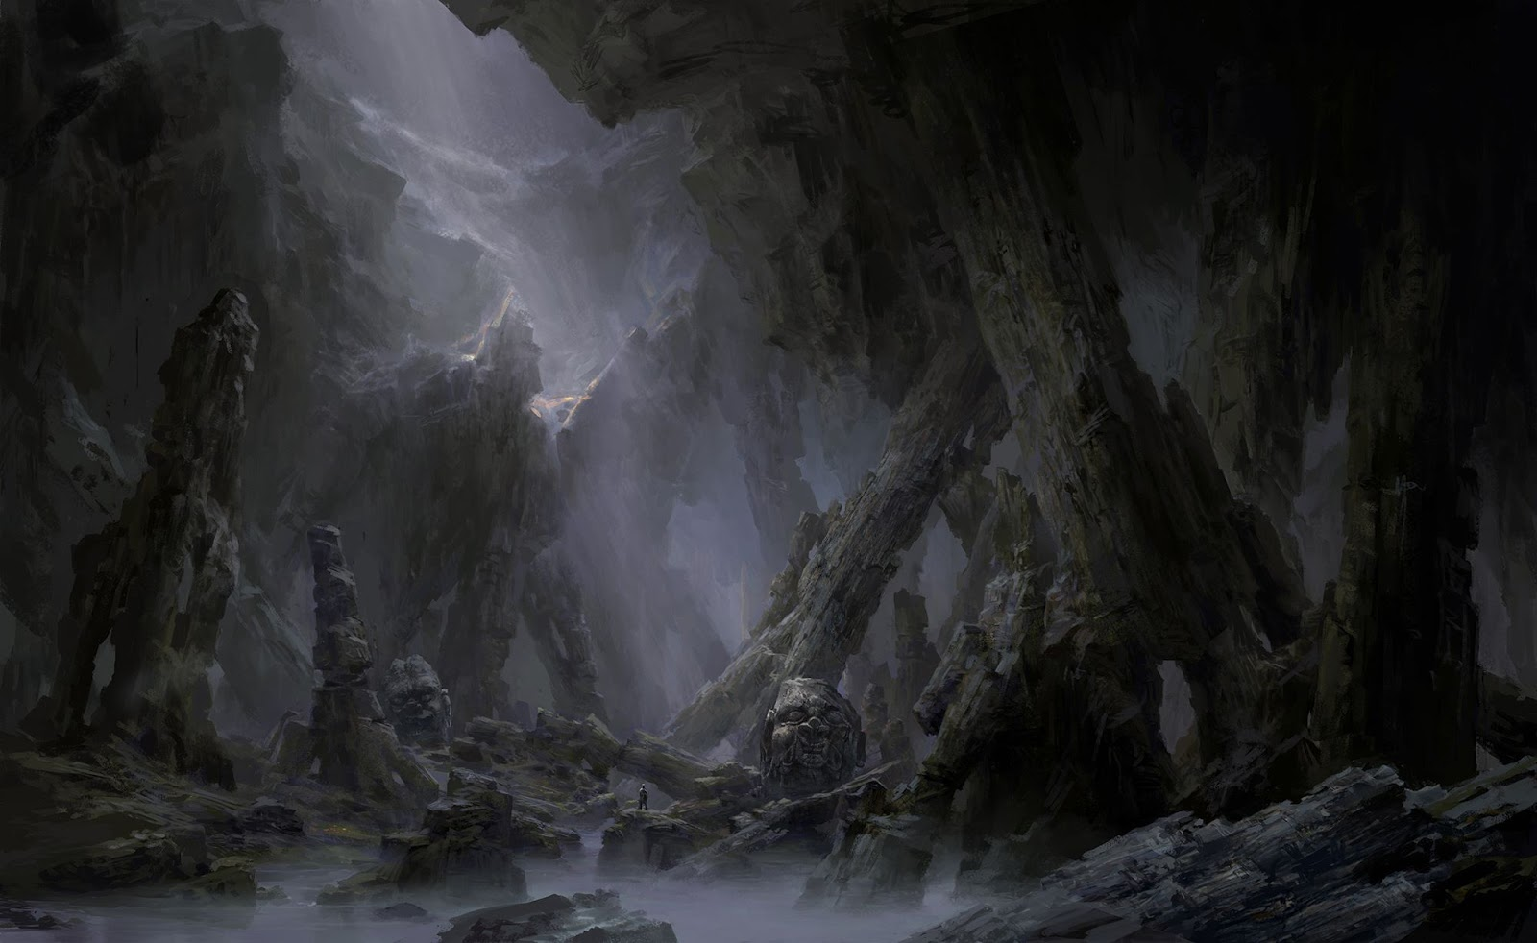

In many winters Thorin trained to be a better dwarf than he was in his early years, sort of. He realizes his mistakes but he can’t get rid of his pridefulness and stubbornness. Every mission he would leave his fellow dwarf and carry out the mission by himself. He would always hog all the glory and tell everyone that he is the greatest and strongest dwarf there ever is. One day a letter from the headquarters was sent telling them to explore a old dwarven fortress in the west and retrieve a important relic from the early dwarf. The letter also said that the known dangers are orcs and ogres. As they traverse in the fortress many enemies tried to attack or ambush them but they handled them with only few casualties. Thorin wanted to show off his skill to his superiors and travelled ahead, but the moment he ran the floor began to crumble and he fell.

As he stands up from falling he stumbled upon a path similar to a dwarven castle. Thorin followed the path guessing that he is close to the relic they needed to find. At the end of the path a fully armoured orc is close to a chest with a symbol of the old forge. He taken upon himself that he can defeat the orc. He reveals himself to the orc saying “come filthy scum let us fight”. The orc laughed replying “go home dwarf I have the treasure you’ve been looking for”. He opens the chest and reveals an old greataxe. The orc added “If you insist of getting this come little dwarf”. Thorin enrages and charges at the orc but before he could get to him the orc slams the axe to the ground and a surge of power pushes knocking Thorin away leaving him unconscious.

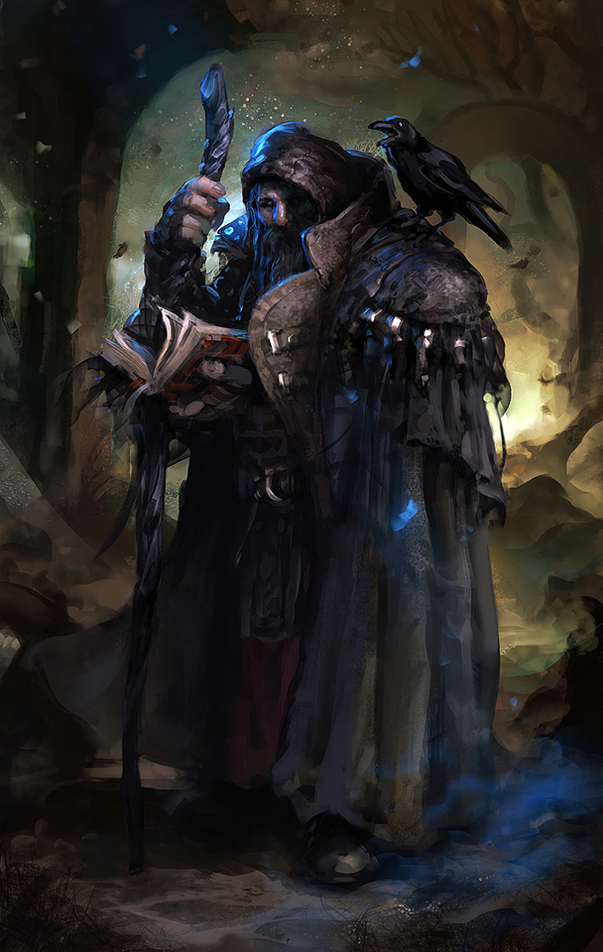

After a few days, Thorin found himself surrounded by the bodies of his bredren and a hooded dwarf with a staff is checking the bodies. Thorin tried to stand up but didn’t have the strength. The hooded dwarf noticed him and said “I did not did this to your friend a band of orc was here days ago but they are gone now. If you like I can help until you can carry yourself again brother”. Thorin knowning he is powerless now, he accepted the help of the stranger and asked his name. The hooded dwarf said “MY name is Vraccas friend; say you could accompany my son to his training”. Thorin got curios and asked the name. Vraccas said “Ulfgar”

While Thorin was resting at Vraccas he said to himself that it would bring only shame to his father if he comes back. He decided he needed to train so his father could be proud of him and prove everyone that he is the greatest dwarf of all. Ulfgar heard him talking and said “well that makes the two us who want to be the greatest dwarf”. Thorin replied “it’s a competition then”. The two then said at the same thing “BRING IT ON”

After 5 years of training Thorin and Ulfgar decided to leave Vraccas and venture the world together. Thorin helped Ulfgar find answer about his long forgotten clan. The adventure was doing great but one day Thorin got injured and Ulfgar left him saying “this is where we part ways brother”. Thorin journey to many places and he heard that the Jomsborg is now in control of a frost witch and everyone is cursed. Thorin now begins to find help and save his clan.

